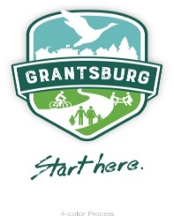
Village of Grantsburg
Special Board of Trustees Meeting
Friday, April 9, 2021

Notice is hereby given that the Board of Trustees for the Village of Grantsburg will hold a Special Board Meeting on Friday, April 9, 2021, at 4:00 p.m. at the Village Office, 316 S. Brad Street, Grantsburg, Wisconsin. The Board will consider the following items and take action as needed:

CALL TO ORDER

A. Roll Call B. Pledge of Allegiance
- VILLAGE BOARD WILL CONVENE INTO CLOSED SESSION pursuant to Wis. Stats. 19.85 (c) “Considering employment, promotion, compensation or performance evaluation data of any public employee over which the government body has jurisdiction or exercises responsibility.”
- VILLAGE BOARD WILL RECONVENE INTO OPEN SESSION pursuant to Wis. Stats. 19.85 (2).
- Possible Hire for Director of Public Works and any other motion(s) from closed session (if any)
- ADJOURNMENT

Prepared by Sheila Meyer, Clerk/Treasurer

Posted: Posted April 7, 2021 at www.grantsburgwi.com; Village Office 316 S Brad Street; Community Center 315 S Robert Street; Grantsburg Public Library 415 S. Robert Street; U.S. Post Office 201 N Pine Street

